
Mini Project Report - 14

Master of Computer Application Semester –I

Sub: Front-End Frameworks and Technologies

Topic: ReactTaskManager

By

Name: Yuvraj Paarth

Reg no.: PROV/ASAC/MCA/7/26/083

Faculty Name: VEERA RAGHAV K

Faculty Signature:_ _________________

Department of Computer Application Alliance University
Chandapura - Anekal Main Road, Anekal Bengaluru - 562 106

0

INDEX

FIG NO NAME OF TABLE PG NO

1 INTRODUCTION 2

2 INPUT CODE 3-9

3 OUTPUT CODE 10

4 CONCLUSION 11

1

INTRODUCTION

Organizing everyday activities becomes more convenient when all tasks are managed in a single place. The React Task Manager is a browser-based application that allows users to add, modify, remove and manage their tasks based on their progress. The application is developed using React.js, JavaScript and CSS, without requiring any backend server.
The application provides features to create new tasks, make changes to existing tasks, remove unwanted tasks and mark completed activities. Every task can be assigned a priority level of high, medium or low, displayed through different coloured labels for easy identification. Users can also sort their tasks using All, Pending and Completed filters. A summary section displays the total number of tasks along with completed and remaining tasks. All task details are stored in the browser's Local Storage, allowing the information to remain available even after refreshing the page.
The application is developed using a component-based structure in React. Different sections are created as reusable components, including TaskForm, TaskList, TaskItem, FilterBar and TaskCount. The main App component controls the application data through React Hooks such as useState and useEffect. Information and functions are shared between components using props. This structure makes the application easier to understand, update and maintain. Through this project, practical use of React components, props, state management, event handling and conditional rendering is demonstrated.

2

INPUT CODE

App.css:

* { box-sizing: border-box; }

body { margin: 0;
font-family: "Segoe UI", Arial, sans-serif; background: #f1f5f9;
color: #1e293b; }

.app {
max-width: 640px; margin: 40px auto; padding: 24px; background: #fff; border-radius: 12px;
box-shadow: 0 4px 16px rgba(0, 0, 0, 0.08); }

h1 { text-align: center; margin-top: 0; }

.form-row { display: flex; gap: 8px; flex-wrap: wrap; }
.form-row input[type="text"] { flex: 1; min-width: 160px; }
input[type="text"], select { padding: 10px;
border: 1px solid #cbd5e1; border-radius: 6px;
font-size: 15px;

3

}

.btn {
padding: 10px 14px; border: 1px solid #cbd5e1; background: #f8fafc; border-radius: 6px;
cursor: pointer; font-size: 14px;
}
.btn:hover { background: #e2e8f0; }
.btn:disabled { opacity: 0.5; cursor: not-allowed; }
.btn.primary { background: #4f46e5; color: #fff; border-color: #4f46e5; }
.btn.primary:hover { background: #4338ca; }
.btn.danger { color: #b91c1c; border-color: #fca5a5; }
.btn.small { padding: 6px 10px; font-size: 13px; }
.btn.active { background: #4f46e5; color: #fff; border-color: #4f46e5; }

.error { color: #b91c1c; margin: 8px 0 0; font-size: 14px; }

.task-count { display: flex; gap: 12px; margin: 20px 0 12px; }
.task-count div { flex: 1;
text-align: center; background: #eef2ff; border-radius: 8px; padding: 10px;

4

}
.task-count strong { display: block; font-size: 22px; }
.task-count span { font-size: 13px; color: #475569; }

.filter-bar { display: flex; gap: 8px; margin-bottom: 12px; }

.task-list { list-style: none; padding: 0; margin: 0; }
.task-item { display: flex;
align-items: center; gap: 10px; padding: 10px;
border-bottom: 1px solid #e2e8f0; }
.task-title { flex: 1; word-break: break-word; }
.task-item.done .task-title { text-decoration: line-through; color: #94a3b8; }

.badge {
padding: 3px 10px; border-radius: 12px; font-size: 12px;
text-transform: capitalize; }
.badge.high { background: #fee2e2; color: #b91c1c; }
.badge.medium { background: #fef3c7; color: #b45309; }
.badge.low { background: #dcfce7; color: #15803d; }

5

.empty { text-align: center; color: #94a3b8; padding: 20px; }

App.jsx:

import { useState, useEffect } from "react";
import TaskForm from "./components/TaskForm.jsx";
import TaskList from "./components/TaskList.jsx"; import FilterBar from "./components/FilterBar.jsx";
import TaskCount from "./components/TaskCount.jsx";

const STORAGE_KEY = "task-manager-tasks";

function loadTasks() { try {
const saved = localStorage.getItem(STORAGE_KEY);
return saved ? JSON.parse(saved) : []; } catch {
return []; }
}

export default function App() {
const [tasks, setTasks] = useState(loadTasks); const [filter, setFilter] = useState("all");
const [editingTask, setEditingTask] = useState(null);

useEffect(() => {

6

localStorage.setItem(STORAGE_KEY, JSON.stringify(tasks));
}, [tasks]);

const addTask = (title, priority) => {
const task = { id: Date.now(), title, priority, completed: false };
setTasks([task, ...tasks]); };

const updateTask = (id, title, priority) => {
setTasks(tasks.map((t) => (t.id === id ? { ...t, title, priority } : t)));
setEditingTask(null); };

const deleteTask = (id) => { setTasks(tasks.filter((t) => t.id !== id));
if (editingTask && editingTask.id === id) setEditingTask(null);
};

const toggleComplete = (id) => {
setTasks(tasks.map((t) => (t.id === id ? { ...t, completed: !t.completed } : t)));
};

const visibleTasks = tasks.filter((t) => {
if (filter === "pending") return !t.completed; if (filter === "completed") return t.completed; return true;
});

const completedCount = tasks.filter((t) => t.completed).length;
7

return (
<div className="app"> <h1>Task Manager</h1> <TaskForm
onAdd={addTask} onUpdate={updateTask} editingTask={editingTask} onCancelEdit={() => setEditingTask(null)}
/> <TaskCount
total={tasks.length} completed={completedCount} pending={tasks.length - completedCount}
/>
<FilterBar current={filter} onChange={setFilter} />
<TaskList tasks={visibleTasks} onToggle={toggleComplete} onEdit={setEditingTask} onDelete={deleteTask}
/> </div>
); }

8

Index.html:

<html>

<head>

<meta charset="UTF-8" />

<meta name="viewport" content="width=device-

width, initial-scale=1.0" />

<title>React Task Manager</title>

</head>

<body>

<div id="root"></div>

<script type="module"

src="/src/main.jsx"></script>

</body>

</html>

9

OUTPUT CODE

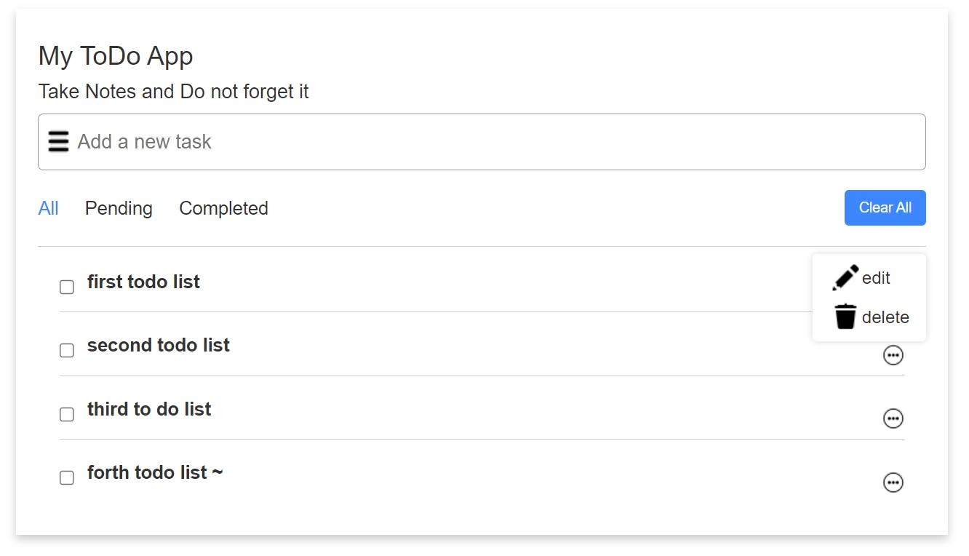

10

CONCLUSION

The React Task Manager meets its objective of giving users a simple and effective way to manage their tasks. All the required features were implemented: adding, editing and deleting tasks, marking tasks as completed, filtering by pending and completed status, assigning priorities, displaying task counts and using reusable components.

Building the project gave practical experience with React fundamentals, including component design, state management with Hooks, passing data through props, handling form input with validation, and rendering lists dynamically. Splitting the interface into reusable components made the code cleaner and easier to extend.

The application can be improved further. Possible additions include due dates, search, drag-and-drop ordering, task categories, user login and a backend database for storing tasks across devices. In its current form, the project is a solid base for learning React and for building larger front-end applications.

11

